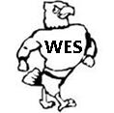
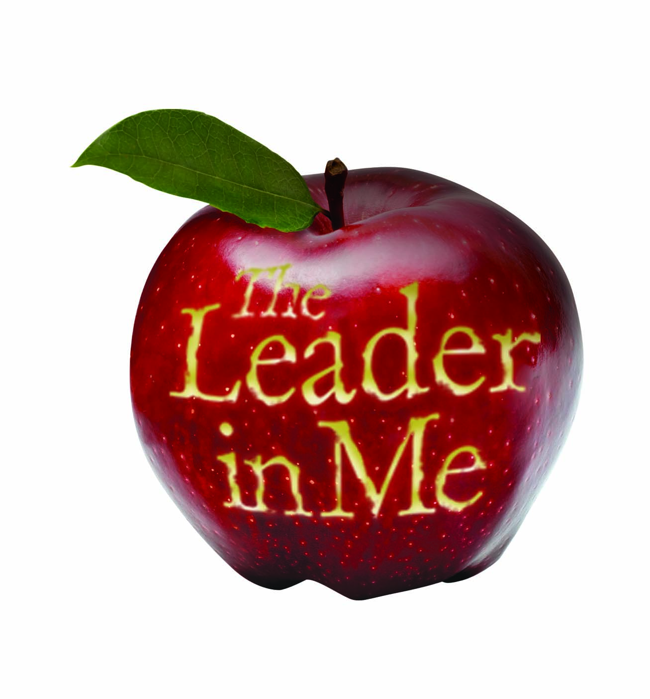
Woodland Elementary 2016-2017
Title 1 School Learning Compact

In order for Woodland Elementary to be an effective school, families and school staff need to synergize to ensure that all children are successful in school. A learning compact is an agreement among groups that firmly unites them. We invite you to be involved in a partnership with your child’s school.

As a parent/caregiver of a Woodland Elementary student, I will strive to:
- Be proactive and begin with the end in mind by sending my child to school on time, appropriately dressed.
- Put first things first by checking my child’s schoolwork and homework on a regular basis.
- Think win-win by striving to create meaningful home school connections through open communication.
- Seek first to understand, then to be understood by communicating with my child’s teacher(s) when I am concerned about my child’s work.
- Synergize by supporting the school staff in maintaining proper discipline.
- Sharpen the saw by spending time each day with my child reading, writing, listening, or just talking.

Parent/caregiver signature: ________________________________________________________________________

As a Woodland Elementary student, I will strive to:
- Be proactive by obeying the rules at home and school, asking my teacher any questions about classwork or homework I do not understand, choosing my own weather and accepting responsibility for my own actions.
- Put first things first by having a plan to set and reach my own goals.
- Think win-win by choosing the best strategy that works for me, using input from my supporters
- Seek first to understand, then to be understood by respecting the cultural differences of others and resolving conflicts peacefully.
- Synergize by applying the 7 Habits outside of school.
- Sharpen the saw by discussing with my parents what I am learning at school.

Student signature: _______________________________________________________________________________

As a Woodland Elementary staff member, I will strive to:
- Be proactive by providing each student a quality instructional program in an integrated, orderly and safe setting.
- Begin with the end in mind by developing programs and activities that meet the diverse needs of our students.
- Put first things first by providing an environment that promotes active learning.
- Think win-win by fostering open communication with our students and families
- Seek first to understand, then to be understood by respecting and valuing the uniqueness of each child and his or her family.
- Synergize by respectfully and accurately informing parents/caregivers of their child’s progress on a regular basis.
- Sharpen the saw by celebrating the victories of my students, myself and our school.

Staff member signature: ___________________________________________________________________________

As the Principal of Woodland Elementary, I will strive to:
- Provide an atmosphere that allows families and teachers to assist students with their growth and application of the 7 Habits which will increase their self confidence, 21st century life and workforce skills and academic progress.

Principal Signature: _______________________________________________________________________________

