Woodland Elementary School

Positive Behavior Interventions

and Supports Handbook

2015 – 2016

We Succeed, No Excuses, No Exceptions

Table of Contents

PBIS at Woodland…………………………………………………………………………p. 3-4

Leader in Me………………………………………………………………………………p. 5

Ways to get a Leadership Ticket...…………………………………………………………p. 6

Student Handbook Behavior Expectations………………………………………………..p. 7-9

Hallway Expectations……………..………………………………………………………p. 10

Restroom Expectations…...……………………………………………………………….p. 11

Media Center Expectations………………………………………………………………..p. 12

Cafeteria Entering/Table/Exiting Expectations…..………………………………………p. 13-15

Office Expectations……………………………………………………………………....p. 16

Sharpen the Saw (Outside Play) Expectations……………………………………...…….p. 17

Special Event Expectations………………………………………………………………p. 18

Car Loading/Unloading Expectations….………………………………………………...p. 19-20

Bus Loading/Unloading Expectations……………………………………..……………..p. 21-22

Woodland Elementary Bus Safety Contract……….………………………………….….p. 23

School-Wide Reward/Recognition System……………………………………………….p. 24

Behavior Clip Chart Parent Letter………………………………………………………....p. 25

Discipline Referral Process…………………………………………………………………p. 26

Guidelines for Behavior Referrals……………………………………………………..…..p. 27-29

Discipline Procedure Flowchart.………………………………………………………...…p. 30

PBIS at Woodland

What is PBIS?

Positive Behavior Interventions and Supports involve a systematic approach for establishing the social culture and individualized behavioral supports needed for schools to achieve both social and academic success for all students.

- Systems: leadership team, evaluation, communication, coaching/training, and policy development
- Practices: instructional lessons, routines, supervision, reinforcement, continuum of consequences and instructional discipline
- Data: central data system (ABE), consistent data entry, comprehensive, efficient referral form, multiple data sources

The goal is for the systems, data, practices, and outcomes to interact with and guide each other so students can be successful.

PBIS: RTI/KSI

PBIS works with the RTI/KSI model.

- Tier 1-Universal Interventions
- For all students in all settings
- Preventative and Proactive
- Success for 80-90% of students

- Tier 2-Secondary Interventions
- Small group interventions
- For students that were not successful with Tier 1 interventions
- 5-15%

- Tier 3-Tertiary Interventions
- Individual Instruction
- Intense procedures
- 1-5%

What does PBIS look like at Woodland?

PBIS at Woodland consists of daily tier 1 behavior instruction for all students in which specific behavior concepts are explicitly taught and modeled based on our school-wide ABE data. This school year, we will continue solidifying our school-wide processes, procedures, and expectations for student behavior. We have developed a system for collecting, analyzing, and sharing discipline data.

Our next steps for the 2015-2016 school year include the implementation of the following:
- New expectations posters around the school that marry our anchor standards (respectful, responsible, and ready) with the Leader in Me language
- School-wide tier 1 behavior instruction
- Referral guidelines
- Referral Flowchart
- Disciplinary Action Flowchart

In addition to our core behavior instruction, we are integrating the Leader in Me as our positive intervention approach to discipline. Through this process our students are explicitly taught the seven habits of leadership through their daily instruction and recognized when they demonstrate them with their behavior choices. Leader in Me initiatives and activities are discussed during the staff Lighthouse Team and Student Lighthouse Team meetings.

School-Wide PBIS Vision

Positive Behavior Interventions and Supports at Woodland are…
Consistent – expectations, procedures, explicit reteaching, interventions, RTI, follow through, all stakeholders
Clear – expectations, plan or process for addressing behaviors, options for interventions and/or consequences, communication, language
Appropriate – interventions and strategies, developmental, consequences fit the behavior

PBIS Team

We have a PBIS team that meets once a month to analyze data and set goals. The team also helps communicate PBIS information to the rest of the staff.

Current members are: Kim Mouser (1st grade representative), Cindy Miller (2nd grade representative), Phyllis Dickerson (3rd grade representative), Kristen Richardson (4th grade representative), Jennifer Ford (5th grade representative), Becky Signorino (special education representative), Dawn Frazier (related arts representative), Eileen Townsend (counselor), Dawn Tarquinio (Principal), Tiffany Jenkins (Family Resource Coordinator) and Ashley Brus (Assistant Principal)

Lighthouse Team

We also have a Lighthouse team that meets weekly to discuss our implementation of the Leader in Me initiatives.

Current members are: Lauren Martin (1st grade representative), Donna Slatton (2nd grade representative), Jeanine Kispert (3rd grade representative), Sara Bollinger (4th grade representative), Shawn Dunaway (5th grade representative), Melissa Smith (special area representative), Tiffany Jenkins (FRC coordinator), Eileen Townsend (counselor), Dawn Tarquinio (Principal), and Ashley Brus (Assistant Principal)

Leader in Me

What is Leader in Me?

Leader in Me is a positive initiative aimed at developing leadership skills in children by teaching them how to live the Seven Habits of Highly Effective People as they were created by Dr. Stephen Covey. Students are immersed in the habits through connections made during daily modeling, instruction, systems, traditions, curriculum, and the school environment.

Seven Habits

- Be Proactive
- Begin with the End in Mind
- Put First Things First
- Think Win-Win
- Seek First to Understand, Then to be Understood
- Synergize
- Sharpen the Saw

Leader in Me at Woodland

Leader in Me lessons are explicitly taught at the beginning of the school year and reinforced frequently. School-wide assemblies are held after each break (fall break, winter break, spring break) to review behavior expectations and their connections to the seven habits.

To support the implementation of the Leader in Me, we have made environmental improvements to include leadership street signs, bathroom paintings, data scoreboards, mission statements, leadership quotes, and connections between the seven habits and school-wide expectations, as well as, the Hardin County Great Eight work ethic standards.

Monday meetings are held weekly to bring the student body and staff together in a celebration of leadership. These meetings consist of our school leadership song, a class fun czar, the presentation of the colors, leadership ticket drawings, golden whisk, Artie the Art Dog, and leadership focus of the week.

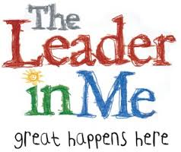

Ways to get a Leadership Ticket
1. Being Proactive
-Level 0 in the hallway.
-Keep my body to myself.
-Walking on the right side of the green line.
-I’m in charge of me and my choices!
“When we can no longer change a situation, we are challenged to change ourselves.”
-Viktor Frankl
2. Begin with the End in Mind
-Study and being prepared for a test.
-Make my lunch choice before going to lunch.
-I think about the outcome of my actions.
“No one can go back and make a brand-new start, my friend; but anyone can start from here and make a brand-new end.” –Dan Zadra
3. Put 1st Things 1st
-Complete my work on time.
-Ready to learn at 7:35.
-Start and finish my breakfast and lunch on time.
“Things which matter most must never be at the mercy of things which matter least.”
-Johann Goethe
4. Think Win-Win
-Sharing
-Taking Turns
-Helping Others
“You don’t have to blow out the other person’s light to let your own shine.”
-Bernard M. Baruch
5. Seek 1st to Understand
-Listen to others with my eyes, ears and heart.
-Consider their perspective and way of thinking.
-Stop and think before I act.
“One friend, one person who is truly understanding, who takes the trouble to listen to us as we consider our problem, can change our whole outlook on the world.”
–Dr. Elton Mayo
6. Synergize
-Teamwork: recognizing each other’s strengths.
-Working for what’s best for the group.
-Giving everyone an equal part.
“We cannot accomplish all that we need to do without working together.” –Bill Richardson

Student Handbook Behavior Expectations

Positive Behavior Interventions and Supports (PBIS)
As a PBIS school, Woodland staff recognizes positive student behavior. Research has found that the more often positive behavior is acknowledged and rewarded the greater chance that it will continue and influence the actions of others. As a part of this, Woodland has adopted school-wide behavior anchors and expectations in all common areas as well as in the classrooms. These anchors and expectations are behaviorally specific and provide observable examples focused on expected behavior rather than misbehavior. Through consistent teaching, acknowledging, and correcting of these anchors and expectations we are setting out students up for behavioral success. Our school-wide PBIS vision is consists of procedures and practices that are consistent, clear and appropriate.

School-wide PBIS Anchors:
1. Be Respectful
2. Be Responsible
3. Be Ready to Learn

Woodland School-Wide Expectations:
1. Respectful
a. Hands, feet, objects and property to self
b. Use appropriate words, volume, tone and body language
2. Responsible
a. Complete all assigned tasks
b. Raise hand for help and to leave assigned area
3. Ready
a. Follow directions the first time given

Leader in Me (LIM)
We are proud to be acknowledged as a Leader in Me school. The Leader in Me is aligned with best-in-class content and concepts practiced by global education thought leaders. It provides a logical, sequential and balanced process to help us proactively design the culture that reflects our vision of the ideal school.

Content from The 7 Habits of Highly Effective People is a key component of the overall The Leader in Me process. The 7 Habits is a synthesis of universal, timeless principles of personal and interpersonal effectiveness, such as responsibility, vision, integrity, teamwork, collaboration and renewal, which are secular in nature and common to all people and cultures. Parents play an important role in supporting their children in this process. With this is mind, we encourage parent involvement through our Parent Lighthouse Team. For more information, Please contact our FRC Coordinator Tiffany Jenkins at 270-352-0172. Additional information regarding parent implementation of the Leader in Me process can be found at http://www.theleaderinme.org/parents/.

The 7 Habits:
1. Be Proactive
2. Begin With the End in Mind
3. Put First Things First
4. Think Win-Win
5. Seek First to Understand, Then to be Understood

6. Synergize
7. Sharpen the Saw

Harassment
Harassment, as defined by the HCS Code of Conduct, is intimidation by threats or physical violence or actual physical conduct, the creation, by whatever means, of climate of hostility, intimidation, or the use of nicknames, written materials or pictures that are lewd, vulgar or profane. Reports of harassment should be reported to the teacher or school office IMMEDIATELY. Please be aware that harassment is an ongoing act and not a single incident.

Bullying
Bullying, as defined by the HCS Code of Conduct, refers to any intentional act by a student or groups of students directed against another student to ridicule, humiliate or intimidate the other student while on school grounds, or at a school-sponsored activity, which acts are repeated against the same student over time. Reports of bullying should be reported to the teacher or school office IMMEDIATELY. Please be aware that bullying is an ongoing act and not a single incident.

Student Discipline
While we believe in a positive approach to behavior management, disciplinary action will be implemented when warranted by student behavior choices. Student behaviors have been classified into three levels to include Level 1 Classroom Handled, Level 2 Classroom Handled / Interventions Implemented, and Level 3 Office Handled. School personnel will utilize the Woodland Elementary Discipline Procedure Flowchart when assisting students with behavior choices.

Level 3 Offenses may include but are not limited to:
1. Fighting
2. Continuous Defiance/Disrespect
3. Vulgarities
4. Continuous disruption that impedes instruction
5. Possession of illegal substances or weapons

*Law officials may be contacted in cases of deliberate threat and/or assault.

Detention
Students may receive After School Detention for the following behavior choices that include, but are not limited to:
• Incomplete assignments
• Not following Woodland expectations
• Dress code violations

Detention is held once weekly from 2:10-3:30. Parents/Guardians are responsible for making arrangements to pick up their child when detention ends at 3:30 on the assigned day. Only authorized adults, on file in the office, will be permitted to pick up students from detention.

School Bus Rules
According to HCAR 06.34, bus rules are made for the SAFETY of all students. Drivers are in charge of their buses, and their first responsibility shall be to the safe transportation of their passengers. Students will be responsible for following regulations for pupils riding school buses as set by the Hardin County Schools.
Annually, parents are provided with the HCS Rules and Regulations for Riding School Buses pamphlet and asked to discuss its contents with their child. In addition, parents and guardians are asked to complete the Student/Parent Transportation Agreement to verify that their child is familiar with the bus safety expectations.

No student will be allowed to ride a bus or get off at an area other than assigned without written permission of a parent AND a bus pass signed by the principal or the designee.

Only school personnel will have access to the bus loading area. No child will be retrieved from the buses at the close of the day.

A student who usually rides a certain bus will be placed on that bus UNLESS we have a written request. If your child is to be picked up or has a transportation change, a note should be sent with the child. Students are to give notes to their teachers when they arrive at school in the morning. In a TRUE emergency, not a daily or weekly event, it may be necessary to call the school; we MUST be able to verify it is you by calling you on a number you have already listed with the school. If it is necessary to call the school to change your child’s transportation, please do so no later than 1:30 pm.

Bus Suspension
The following is a copy of a Hardin County Schools Bus Incident Report. A bus driver will complete this form if and when a student does not follow the bus rules. Additional rules are found in the Hardin County Schools Code of Conduct. Depending on the reason for the bus suspension, it is possible that a student may not be able to ride a bus on a field trip. Please refer to the disciplinary options chart on the School Bus Incident report.

HALLWAY EXPECTATIONS
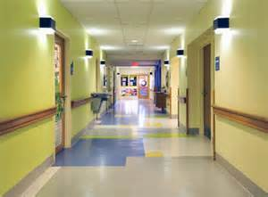
RESPECTFUL | RESPONSIBLE | READY | LEADER IN ME  HOW I show the 3Rs
Voice level 0  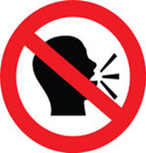  Hands, feet, body and objects to self  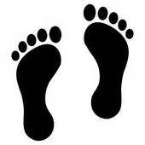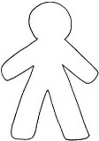  Use your BEST MANNERS  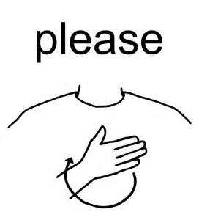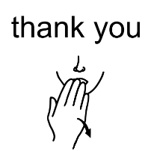  Be a leader | Walking feet on green line  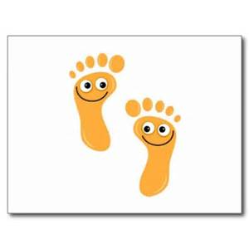  Walk shortest distance to destination following flow of traffic  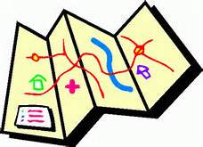  Keep our school clean  Check clothing:  shirt tucked  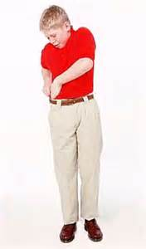 | Eyes looking forward on TEACHER  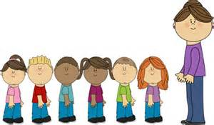  Have all of your materials  Be aware of what is going on around you | Habit 1  Be Proactive;  You're in Charge.  Habit 2  Begin with the End in Mind;  Have a Plan.
RESTROOM EXPECTATIONS
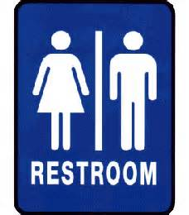
RESPECTFUL | RESPONSIBLE | READY | LEADER IN ME  HOW I show the 3Rs
Voice level 1  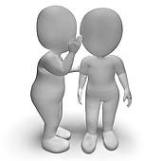  Keep HANDS and EYES to self  Be a leader | Go  Flush  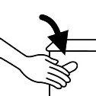  Wash  Go quickly  Keep our restrooms clean  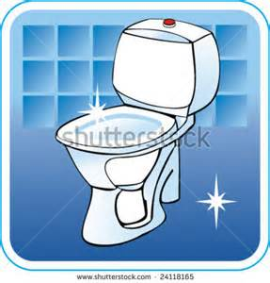 | Check clothing:  shirt tucked  Refocus, join your class and be ready to learn  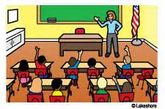 | Habit 1  Be Proactive;  You're in Charge.  Habit 2  Begin with the End in Mind;  Have a Plan.
MEDIA CENTER EXPECTATIONS
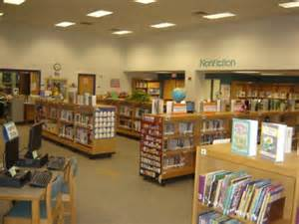
RESPECTFUL | RESPONSIBLE | READY | LEADER IN ME  HOW I show the 3Rs
Voice level 1  Take care of your books, computers, and other materials  Clean up after yourself  Be a leader | Return books  on time  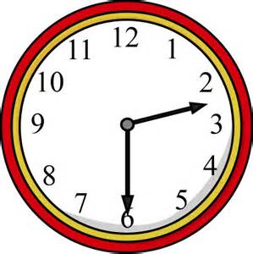  and in cart  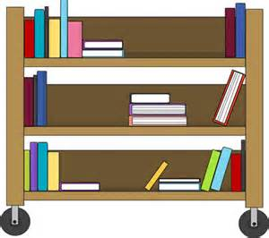  Use and return  shelf marker  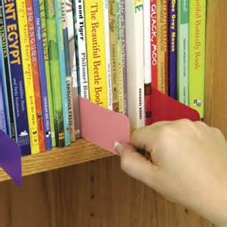 | Have your card  Focus  Ears listening  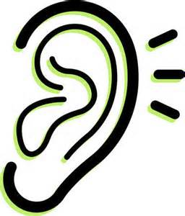  Sit seat to seat  back to back  when sitting at tables  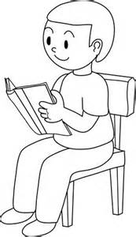 | Habit 4  Think  Win-Win;  Everyone Can Win.  Habit 6  Synergize;  Together Is Better.

ENTERING CAFETERIA EXPECTATIONS
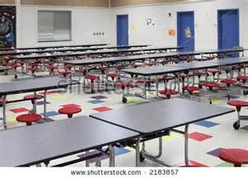
RESPECTFUL | RESPONSIBLE | READY | LEADER IN ME  HOW I show the 3Rs
Voice level 0  in line  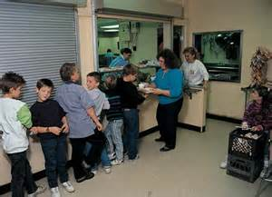  In service lines speak only to ADULTS using voice level 2  Use your BEST MANNERS  Be a leader | Hands, feet, body and tray to self  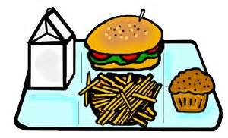  Wait patiently for your turn  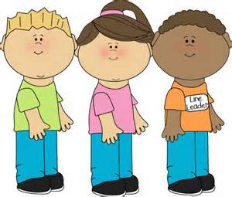  Face forward | Single file line  Make choices quickly  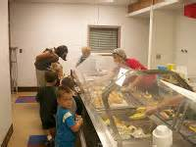  Know your  LUNCH NUMBER  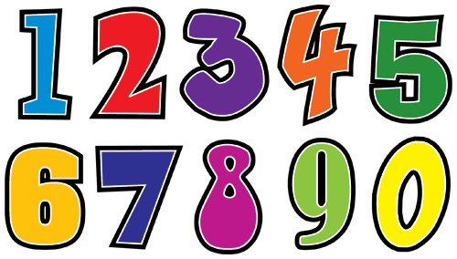 | Habit 2  Begin with the End in Mind;  Have a Plan.  Habit 4 Think  Win-Win;  Everyone Can Win.
CAFETERIA TABLE EXPECTATIONS
RESPECTFUL | RESPONSIBLE | READY | LEADER IN ME  HOW I show the 3Rs
Voice level 2  Eat with manners: mouth CLOSED while chewing  Eat and touch only YOUR FOOD (no sharing or trading)  Be a leader | Raise your hand if you NEED HELP  Stay in seat unless you have adult permission to get up  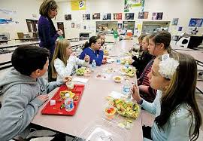 | Use time to EAT  Clean up area (table and floor)  Be ready to exit table | Habit 3  Put First Things First;  Eat First, Then Talk.  Habit 5  Seek First to Understand, Then to Be Understood; Listen Before You Talk.
EXITING CAFETERIA EXPECTATIONS
RESPECTFUL | RESPONSIBLE | READY | LEADER IN ME  HOW I show the 3Rs
Voice level 0  Wait at dishroom door for lunch worker to call you in  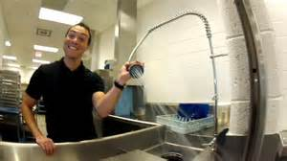  Be a leader | Pick up ANY trash  or food  (even if it isn’t yours)  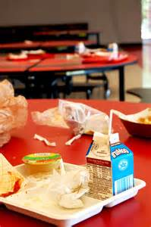  Keep the cafeteria CLEAN  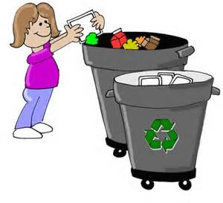 | Face forward  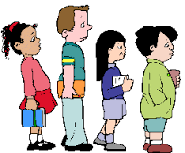  Wait at the  marked spot to leave on level 0 | Habit 2  Begin with the End in Mind;  Have a Plan.  Habit 4  Think  Win-Win;  Everyone Can Win.
OFFICE EXPECTATIONS
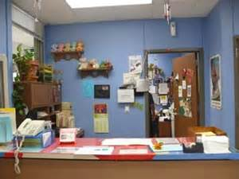
RESPECTFUL | RESPONSIBLE | READY | LEADER IN ME  HOW I show the 3Rs
Wait at  front counter line  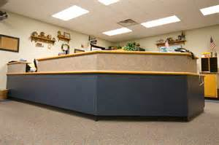  Use your  BEST MANNERS  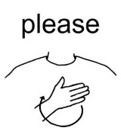  Talk to adults when addressed (do not interrupt)  Be a leader | Take care of the task you were given  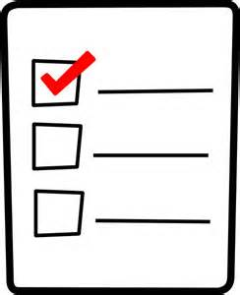  Go to office and go right back to class | Respond and speak clearly in complete sentences  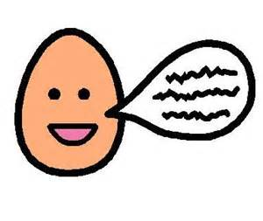 | Habit 1  Be Proactive;  You're in Charge.  Habit 2  Begin with the End in Mind;  Have a Plan.
SHARPEN THE SAW (Outside Play)
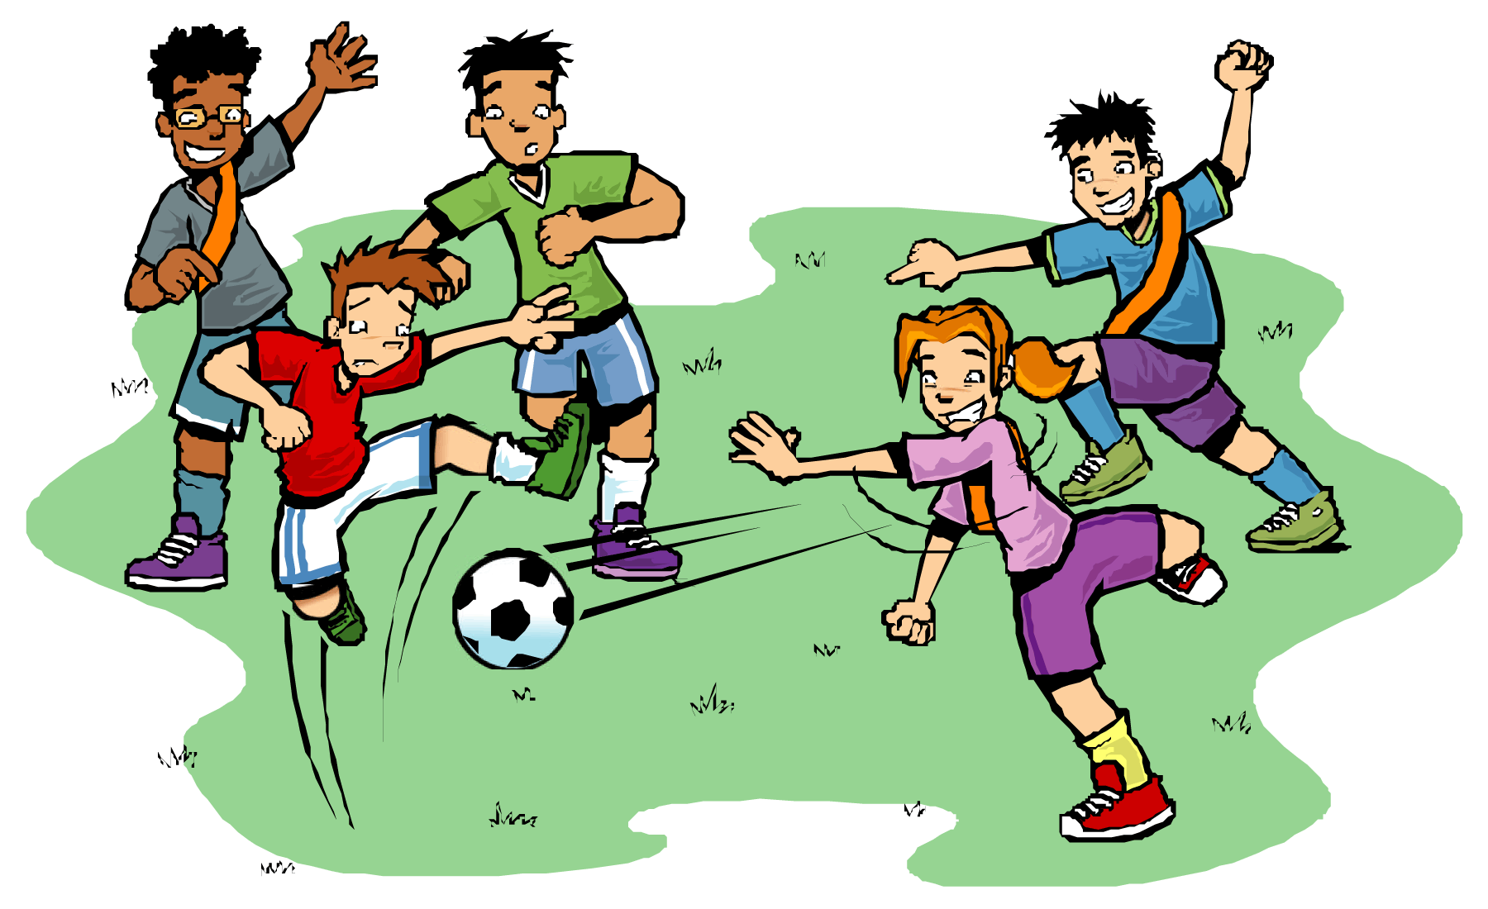
RESPECTFUL | RESPONSIBLE | READY | LEADER IN ME  HOW I show the 3Rs
Use only KIND words  Include others in play and share  Hands and feet to self  Be a leader | Use equipment correctly  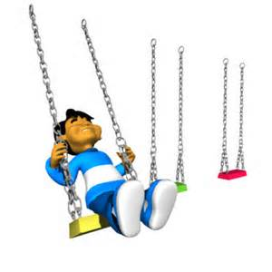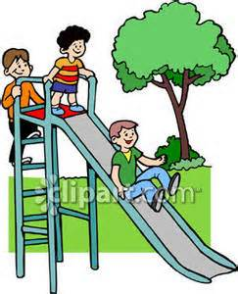  Stay out of rocks  Stay in specified areas  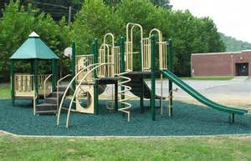  Observe your surroundings | Line up quickly when you hear the signal  Collect all equipment  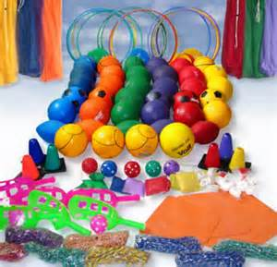  Walk back into school on level 0 | Habit 4  Think Win-Win  Everyone Can Win  Habit 5  Seek First to Understand, Then to Be Understood; Listen Before You Talk  Habit 6  Synergize  Together Is Better
SPECIAL EVENT EXPECTATIONS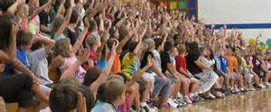
RESPECTFUL | RESPONSIBLE | READY | LEADER IN ME  HOW I show the 3Rs
Listen with your eyes, ears and your heart  Hands, feet, body and objects to self  Sit with your class in your area  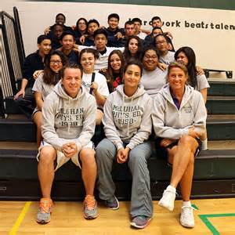  Be a leader | Stay in line  Enter and exit quietly  voice level 0 | Quiet hands  Quiet feet  Exit from STEPS only  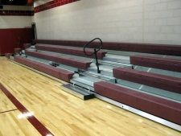 | Habit 4  Think Win-Win;  Everyone Can Win.  Habit 5  Seek first to understand, then be understood

CAR RIDER – LOAD
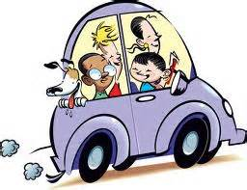
RESPECTFUL | RESPONSIBLE | READY | LEADER IN ME  HOW I show the 3Rs
Voice level 0 in HALLWAY  Noise level 0 in Media Center  Be a leader | Walk to Media Center on green line  Know your  PICK-UP NUMBER  Walk to your car and carefully get in  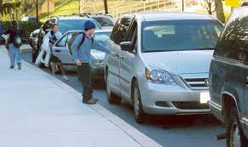 | Sit in designated area  Listen for your  pick-up number  Walk to exit when called | Habit 1  Be Proactive;  You're in Charge.  Habit 2  Begin with the End in Mind;  Have a Plan.
CAR RIDER – UNLOAD
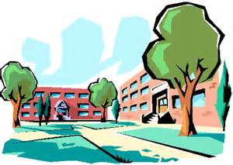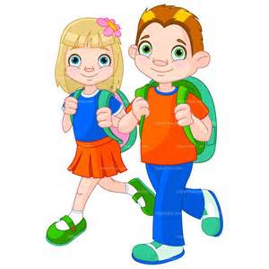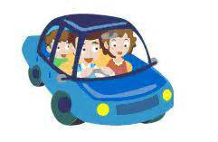
RESPECTFUL | RESPONSIBLE | READY | LEADER IN ME  HOW I show the 3Rs
Voice level 2 while outside  Enter building using hallway expectations  level 0 walking  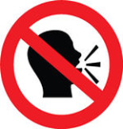  Be a leader | Walk on sidewalk on yellow line  Safely exit vehicle when instructed  to do so  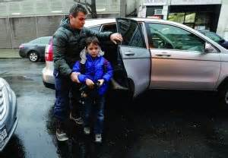 | Be ready to exit your vehicle  Have all your things  Shirt tucked | Habit 1  Be Proactive;  You're in Charge.  Habit 2  Begin with the End in Mind;  Have a Plan.
BUS LOADING EXPECTATIONS
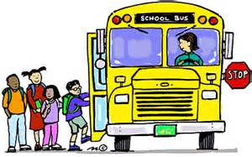
RESPECTFUL | RESPONSIBLE | READY | LEADER IN ME  HOW I show the 3Rs
Voice level 0 in hallway  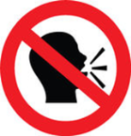  Hands, feet, body and objects to self  Treat others with respect: FOLLOW DIRECTIONS first time given  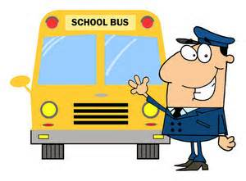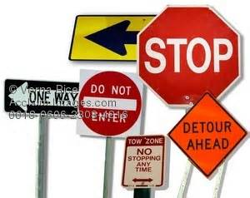  Be a leader | Stay out of rocks  Walking FEET on yellow line | Sit seat to seat  back to back  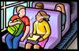  Voice level 2 outside building  Know your shape and bus number  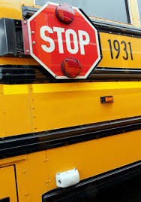 | Habit 1  Be Proactive;  You're in Charge.  Habit 5  Seek First to Understand, Then to Be Understood; Listen Before You Talk.
BUS UNLOADING EXPECTATIONS
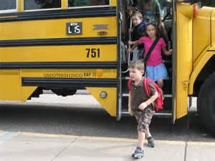
RESPECTFUL | RESPONSIBLE | READY | LEADER IN ME  HOW I show the 3Rs
Voice level 2 outside of building  When dismissed, STAND, exit ROW BY ROW  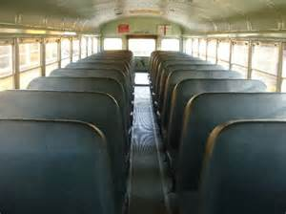  Hands, feet, body and objects to self  Be a leader | Walking FEET on yellow line | Voice level 0 when entering building  Follow hallway expectations | Habit 1  Be Proactive;  You're in Charge.  Habit 2  Begin with the End in Mind;  Have a Plan.
Woodland Elementary Bus Contract

As a leader of Woodland Elementary, I will demonstrate the following safe and respectful behaviors on the bus:

- Respect the bus driver by following his/her directions and using appropriate language.
- Stay seated until it is time to exit the bus.
- Remain seat to seat with my bottom on the seat cushion.
- Remain back to back with my back on the seat back cushion.
- Keep all body parts to myself such as my hands, arms, legs and feet.
- Keep all loose items stored in a safe place.
- Speak to others at a level between a whisper (1) and a normal talking voice (2).
- Use kind words when speaking to others to include students and the bus driver.

I understand that these behaviors are expected of me anytime I ride the bus. I know that if I do not follow these safe and respectful expectations, I may not be allowed to ride the bus as my behavior choices affect the safety of myself, the other riders, and the bus driver.
Student Signature: _________________________ Date: __________
Assistant Principal: ________________________ Date: __________
Principal: ________________________________ Date:___________
School-Wide Reward/Recognition System

Leadership Clip Chart
Each classroom is equipped with a leadership clip chart to monitor student behavior. Students begin each day with their clip on “Being a Leader” and can move their clip up and down the chart as dictated by their behavior choices. Positive behaviors warrant a clip up, while negative behaviors warrant a clip down. If a student clips all the way up and off the chart, they are allowed to clip onto an adult within the building.

Leadership Tickets
Students who exhibit the Leader in Me seven habits during their daily interactions and work are rewarded with a leadership ticket as is shown below.
I caught ________________________
being a LEADER!
1 Be Proactive
2 Begin with the End in Mind
3 Put First Things First
4 Think Win-Win
5 Seek 1st to Understand
6 Synergize

These tickets are turned into the leadership buckets in the office. During the Friday morning meeting, one ticket is selected from each bucket and the selected student is recognized before the student body and staff. Following the drawing, leadership tickets for each habit are counted and the data is displayed on the scoreboard outside the cafeteria doors.

Star Student Necklaces
Star student necklaces are awarded to those students whose leadership ticket is drawn during the Friday meeting assembly. One necklace is awarded for each habit represented on the leadership ticket.

Golden Whisk
Each week the golden whisk is awarded to the class that exhibits the best leadership behaviors in the cafeteria. The winning class is chosen by the cafeteria staff and announced during the Friday meeting.

Artie the Art Dog
Each week Artie the Art Dog is awarded to the class that has earned the most Dojo points for the week in art class. The winning class is chosen by the art teacher and announced during the Monday meeting.

Treble Makers
Each week the Treble Makers award is awarded to the class that has shown the most leadership in music class for the week. The winning class is chosen by the music teacher and announced during the Monday meeting.

Most Valuable Class
Each week the MVC award is awarded to the class that has shown the most leadership in P.E. for the week. The winning class is chosen by the P.E. teacher and announced during the Monday meeting.

Behavior Clip Chart Parent Letter

Dear Parents,
We will be using a colored “clip chart” to monitor our behavior and our choices. Your child will have a clip that they will physically move up or down the chart, depending on their choices. Please keep in mind that your child may not move every single day. For your child to move up, they must go above and beyond in their behavior choices! The chart below explains how the clip chart works.

Blue  Outstanding Leader | If you move to Outstanding Leader, you’ll get to xxxxxxx (rewards are based on teacher’s choice).
Orange  Great Leader | As you continue to make good choices, you’ll advance to “Great Leader.”
Purple  Good Leader | Making a good choice will help you move up to the purple section of our chart.
Green  Ready to learn | You will get to start out each day on “Being a Leader.” You will move your clip up or down depending on your choices each day.
Pink  Leadership off Track | If you receive a warning, you will move your clip down to help you remember to think about your choices.
Yellow  Needs Improvement | If you continue to make poor choices, you will move to “Needs Improvement.” (Explain Needs Improvement for your room here)
Red  Struggling with Leadership | If you still choose to make inappropriate decisions, you will move to “Struggling with Leadership.” You will xxxxxxx (consequences based on teacher’s choice).

I believe this will be a positive way for students to monitor their choices and will give them behavior goals to strive for! As always, if you have any questions, please don’t hesitate to contact me!
Sincerely,
xxxxxxxx

Discipline Referral Process

Minor Discipline Referrals

Students will receive a minor discipline referral for behaviors that occur three continuous times. Behaviors that warrant a minor discipline referral include:

Inappropriate Language Physical Contact/Physical Aggression
Defiance/Disrespect Property Misuse Technology Violation
Missing Assignment Disruption/Noise Level Dress Code Violation

Automatic minor discipline referrals will be completed for first time offenses that are overtly offensive (ex. curse words).

Classroom teachers will address behaviors documented on minor discipline referrals unless they request administrative intervention. All minor referral documentation is sent to the office for record keeping. A copy of the referral is provided to the teacher, as well as, the parent.

Major Discipline Referrals

Students will receive a major discipline referral for continuous behaviors that have already been documented on three minor referral forms. Behaviors that warrant a major discipline referral include, but are not limited to:

Inappropriate Language Fighting/Physical Aggression
Defiance/Disrespect Lying/Cheating Harassment
Weapons Skipping Class Property Damage
Alcohol/Drugs Theft/Forgery Technology Violation

Automatic major discipline referrals will be completed for first time offenses that cause an extreme disruption to the educational process (ex. threatening).

Major discipline referrals will be addressed by administration and appropriate action will be taken to resolve the issues. All major referral documentation is sent to the office for record keeping. A copy of the referral is provided to the teacher, as well as, the parent.

Important Notes

Behavior referrals are completed and submitted online electronically through ABE (Alternate Behavior Educator).

Students who are sent to the office for behavior are required to come with a completed discipline referral and academic work to complete.

Special Area teachers who complete a discipline referral will provide the documentation to the classroom when they arrive to pick up their students.

Guidelines for Behavior Referrals

Level 1 Behaviors: Classroom Handled

- Out of chair/off task
- Lying
- Not completing homework/classwork
- Inappropriate language
- Tattling
- Excessive socializing
- Talking back/disrespect
- Talking in hall
- Dress code violations
- Blurting out
- Cheating
- Noise level
- Constant chatter
- Calling out
- Stirring the pot
- Line skills
- Not following rules/Woodland expectations
- Non-proactive behavior (worrying about everyone else)
- Peer cruelty

Level 2 Behaviors: Classroom Handled – Strategies Needed

- Disturbing others/instruction
- Screaming
- Defiance
- Rude/Hateful/Disrespectful
- Hands on others
- Continued incomplete homework/classwork
- Disrespectful to classmates
- Continued inappropriate language
- Cheating
- Continuous disruption
- Non-Compliance
- Talking back
- Horseplay/goofing off
- Refusal to accept a redirection
- Writing/passing inappropriate notes
- Property misuse
- Unkind words
- Taking away from others learning
- Out of control crying or shouting out
- Stealing
- Bathroom property misuse

Strategies for Addressing Behaviors (“3 before me”)

- Contracts
- Time in another classroom
- Time out/isolation
- Brain break
- Private conference (w/ teacher or another adult)
- 2nd chances/detention assigned
- Break with time limit
- Procedure review
- Calming strategies
- Re-direct to another activity/group
- Dojo
- Journaling (writing about what is bothering them)
- Silent lunch
- Cool down in the hallway
- Clip chart
- Job assignment
- Loss of privilege
- Parent contact
- Preferential seating
- Better choices note
- Bathroom buddy
- Walking lifetime
- Compliment great examples
- “Quiet place” for de-escalation
- Distance yourself from behavior
- “Right to pass”
- Planned ignoring
- Modeling/expectation review
- Personalized data chart
- Specific feedback
- Behavior motivators assessment
- Peer recognition
- Leadership reflection

Level 3 Behaviors: Office Handled

- Theft (instructional disruption, continuous issue, item of considerable value)
- Threatening others (verbal to cause bodily harm)
- Fighting
- Making noises that cease instruction
- Refusing to physically move
- Destruction of property
- Hurting self/others
- Excessive/directed swearing
- Weapons
- Sexual issues
- Unsafe behavior after re-direction
- Physical aggression that causes harm to self or others
- Continuous defiance/disrespect
- Bullying (continuous negative behaviors toward another person over time)
- Continuous disruption that impedes instruction

Discipline Procedure Flowchart
Classroom Environment and Teacher Strategies
Level 1
Teach expectations, rules & procedures
Reinforce positive behaviors
Problem solve with students(s)
Continue building relationship(s)
Implement 3 strategies from the guidelines chart
Elicit parent/guardian’s help

Yes

Send student(s) to office with referral in hand.

lkjlkjasdfdsfs
Observe Problem Behavior

Level 3
Level 2
Determine if behavior is
Level 2, or 3
Follow Classroom Management System
Send student to office with referral in hand.

Office Responses

Follow guidelines for behavior referrals with strategies and a referral form. Contact parent/guardian and document contact in IC.
Interview

Determine consequence and/or intervention

Behavior continues…

Make parent contact

Follow up with referring staff member when appropriate
No

File Referral Form
(Keep one copy and send one copy to the office for data entry.)

Follow up with student(s) as appropriate

